编译原理
实验报告书

班级：2022级计算机科学与技术2班
学号：226001624
姓名：顾凯琪

2024年 6月 13日

摘要：
预测分析法旨在通过构造预测分析表并使用栈实现程序设计语言的语法分析，以理解预测分析法和递归子程序法的区别与联系。实验将非终结符内码从128开始标记，使用规则号表示预测分析表中的元素，并通过(非终结符, 终结符, 规则号)三元式初始化分析表。最终，总控程序根据分析表判断输入流是否符合文法定义，并填充符号表供后续代码生成使用。

实验目的：
目的在于通过完成预测分析法的语法分析程序，深入理解预测分析法与递归子程序法之间的区别与联系。具体目标包括构造预测分析表，并利用该分析表和栈来实现程序设计语言的语法分析。此外，要求对源程序的内码流进行预测分析，输出其是否符合文法定义，并在必要时处理说明语句，以填充符号表，为后续代码生成做好准备。

任务概述
- 构建预测分析表：

- 根据给定的文法规则和内码表，构造预测分析表。该表使用规则号表示每个解析步骤。
- 实现总控程序：

- 使用栈来进行语法分析。初始时栈中包含起始符号和输入流的结束标记。
- 总控程序根据预测分析表和输入流，逐步匹配和推导，判断输入流是否符合文法定义。
- 处理符号表：

- 在语法分析过程中，根据需要填充符号表，为后续代码生成提供支持。
- 输出分析结果：

- 判断输入流是否为文法定义的句子，并输出相应结果。若输入流符合文法定义，输出“是”；否则输出“否”。

实验依据的原理
上下文无关文法（CFG）：

实验中的文法已经被转换为无回溯和无左公因子的形式，确保每个非终结符在不同上下文中有唯一的选择，从而可以构造预测分析表。
预测分析表（Parsing Table）：

预测分析表是一个二维数组，其中行表示非终结符，列表示终结符，单元格的值是规则号。通过查表，可以决定在某个非终结符和终结符的组合下应该应用哪个文法规则。
预测分析表的构造基于FIRST集和FOLLOW集，确保分析过程中的每一步都有唯一选择。
栈机制：

分析过程使用一个栈，初始状态下栈中包含起始符号和输入流的结束标记。通过栈的推入和弹出操作，模拟语法分析过程。
当栈顶为非终结符时，通过预测分析表查找对应的规则，并将规则右部的符号逆序推入栈中。
当栈顶为终结符时，与输入流的当前符号比较，若匹配则弹出栈顶并消费输入符号，否则报错。
总控程序：

总控程序控制整个分析过程，负责初始化栈和输入流，进行语法匹配和符号表填充。
在匹配过程中，根据预测分析表决定如何推导和匹配输入符号，判断输入流是否符合文法定义。
符号表：

在分析过程中，符号表用于记录标识符及其属性，以支持后续的语义分析和代码生成。

程序设计思想
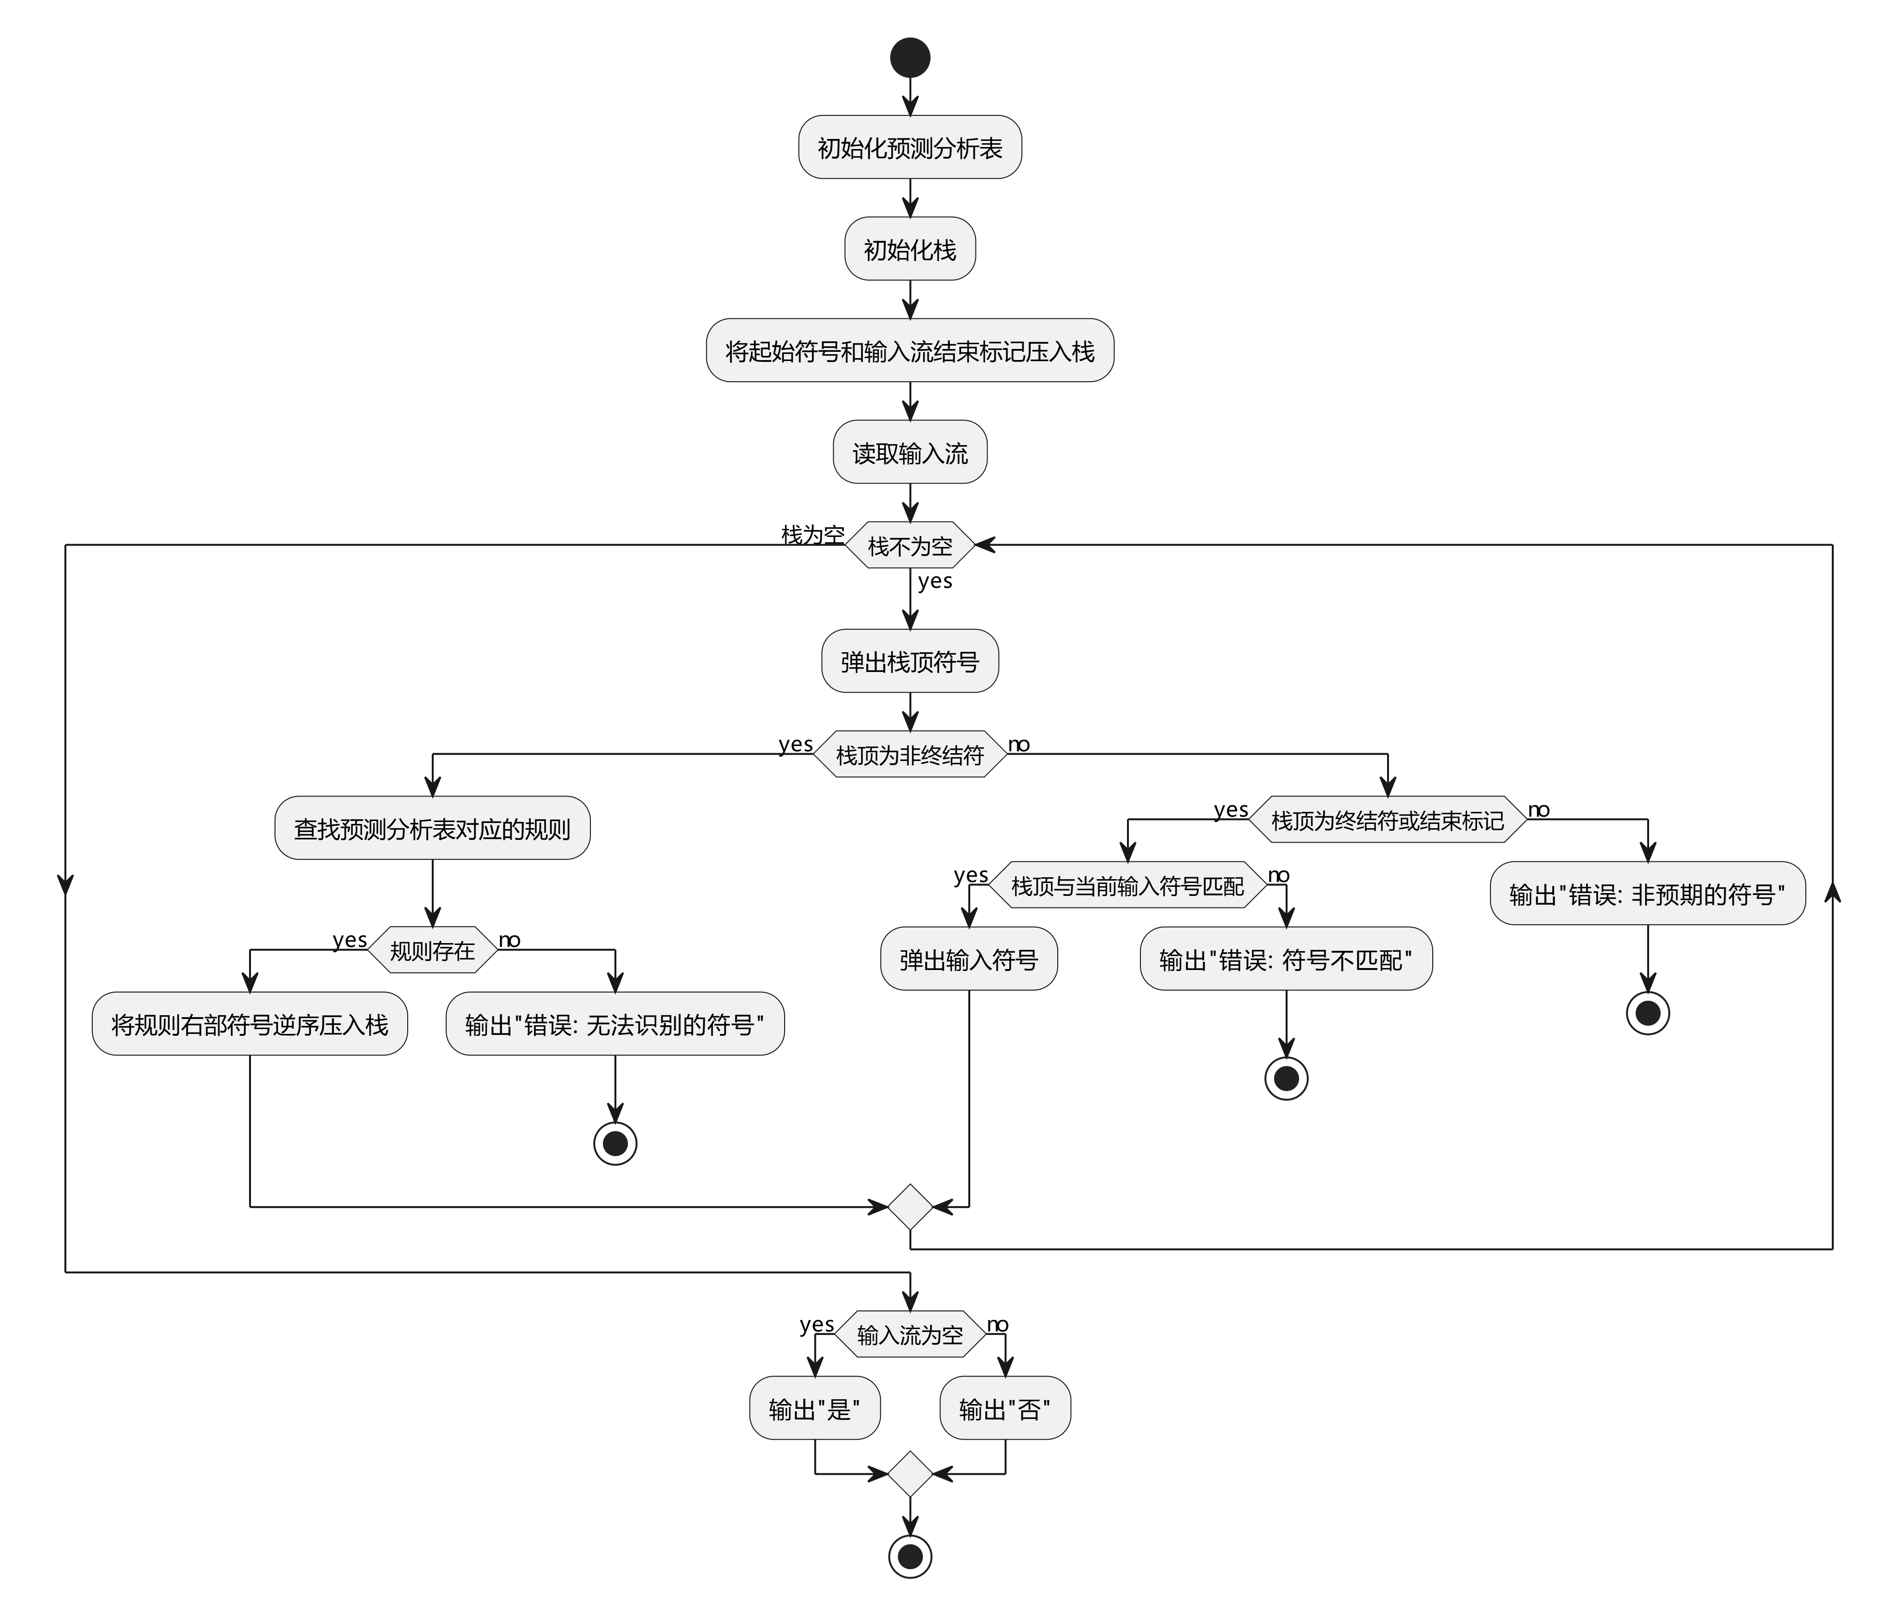

实验结果分析
输入的文法如下
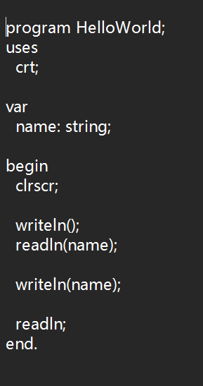

计算FIRST集：
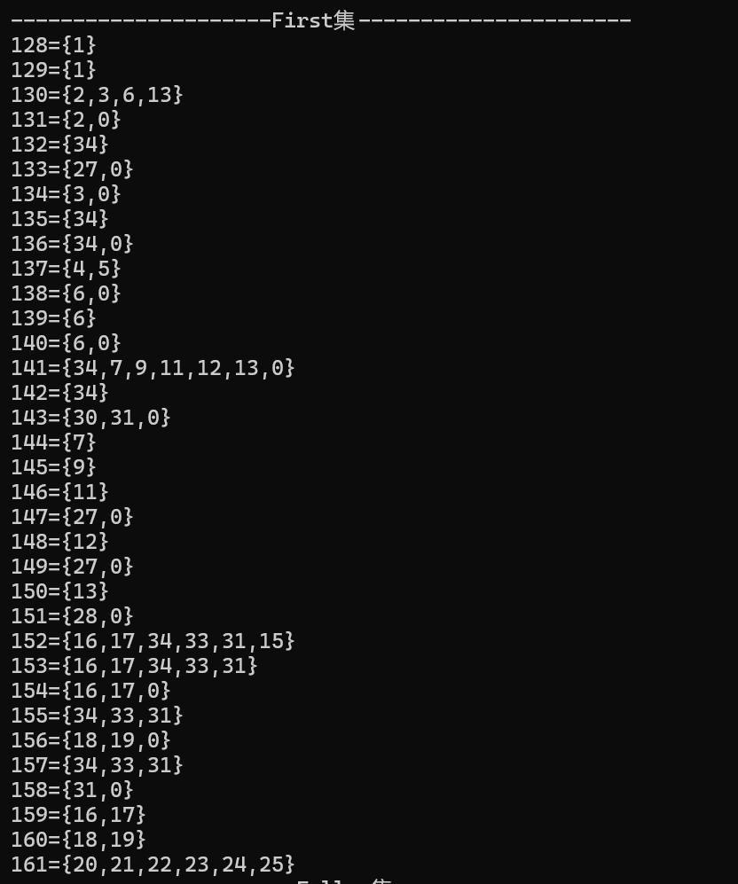

计算FOLLOW集：
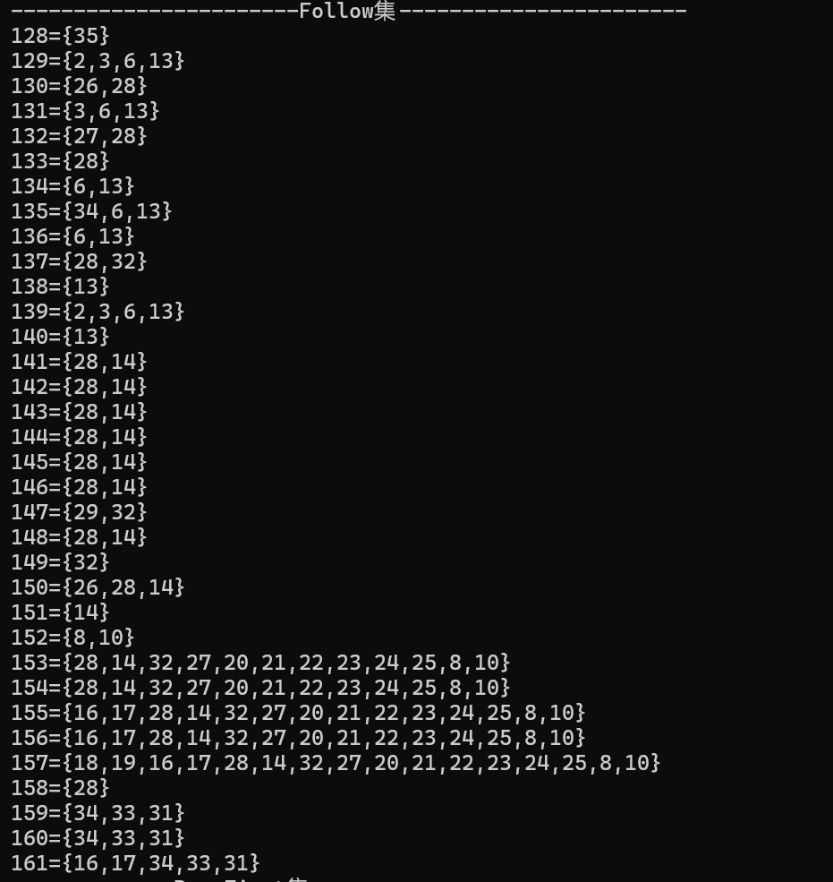

根据规则判断是否是LL（1）文法：
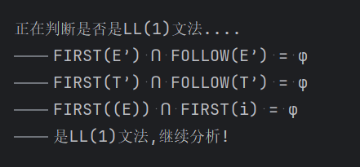

进行预测分析表构建：
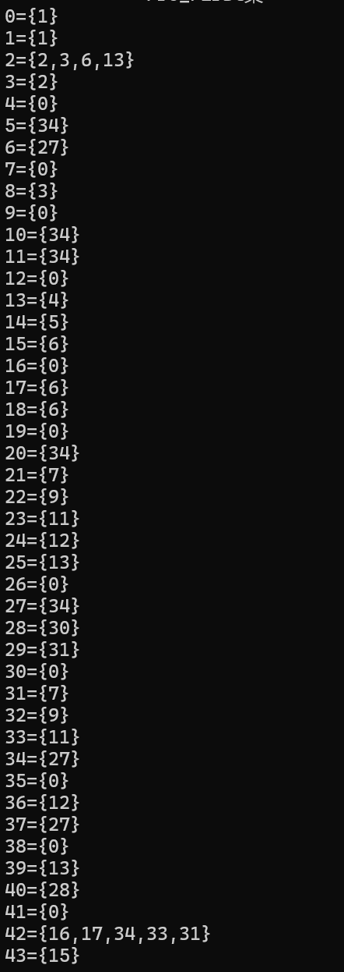

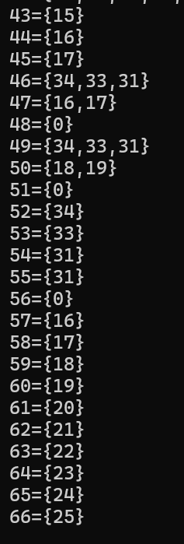

分析结果：
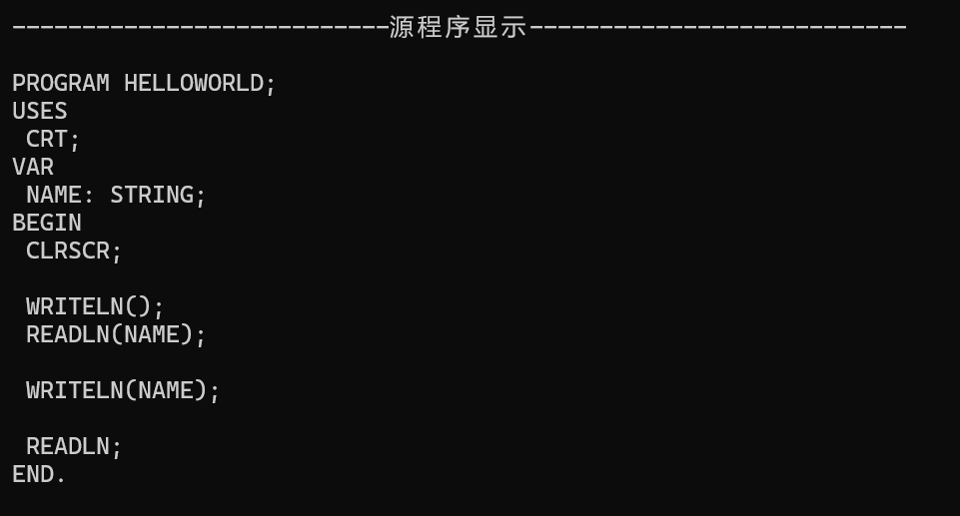
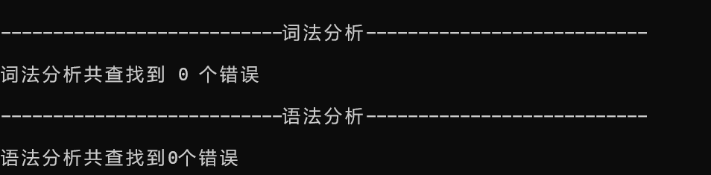
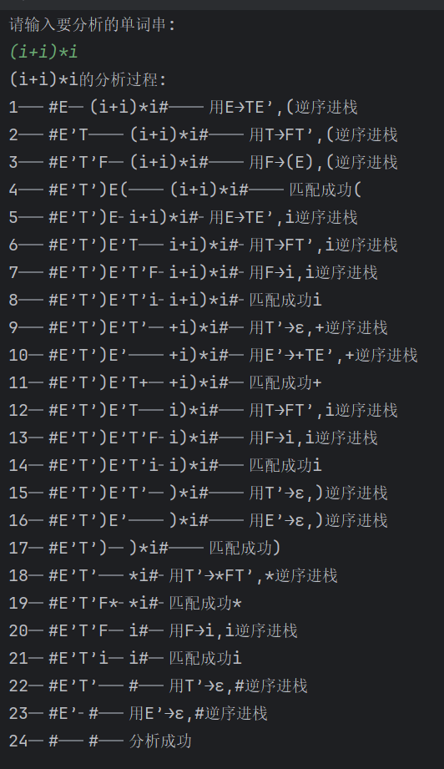

7、总结
在本次实验中，我们深入学习了预测分析法作为一种自顶向下的语法分析技术的基本原理和实现方法。预测分析法通过构建预测分析表，并利用栈来进行语法分析，相较于递归子程序法，它具有不需要回溯的优势，因而在效率上更为高效。
我们首先成功地构建了预测分析表，这是整个语法分析过程的关键。通过分析文法的FIRST集和FOLLOW集，我们确立了每个非终结符与终结符组合的预测分析规则，将其以规则号的形式存储在表中，这样做既减少了存储空间，又提高了分析速度。
在实现总控程序时，我们根据预测分析表的规则，初始化栈并将起始符号和输入流的结束标记压入栈中。程序通过循环处理栈顶符号，根据其类型（非终结符或终结符）进行相应的匹配和推导。对于符合文法的输入流，程序能够正确输出“是”，对于不符合文法的输入流，则会相应输出错误信息并终止分析过程。

通过这次实验，我们验证了预测分析法在语法分析中的有效性和实用性。它不仅帮助我们理解了语法分析的整体流程，还为后续的语义分析和代码生成提供了基础。

附录：代码

package exp;
import java.io.BufferedReader;
import java.io.File;
import java.io.FileReader;
import java.util.ArrayList;
import java.util.Collection;
import java.util.HashMap;
import java.util.HashSet;
import java.util.Iterator;
import java.util.LinkedList;
import java.util.Queue;
import java.util.Scanner;
import java.util.Set;
import java.util.Stack;
public class Parser {
public static final String PATH = "C:\\Users\\asus\\IdeaProjects\\bianyiyuanli\\out\\production\\bianyiyuanli\\1.txt";
private static String START;
private static HashSet<String> VN;
private static HashSet<String> VT;
private static HashMap<String, ArrayList<ArrayList<String>>> MAP;
private static HashMap<String, String> oneLeftFirst;
private static HashMap<String, HashSet<String>> FIRST;
private static HashMap<String, HashSet<String>> FOLLOW;
private static String[][] FORM;
private static HashMap<String, String> preMap;
public Parser() {
}
public static void main(String[] args) {
init();
identifyVnVt(readFile(new File("C:\\Users\\asus\\IdeaProjects\\bianyiyuanli\\out\\production\\bianyiyuanli\\1.txt")));
reformMap();
findFirst();
findFollow();
if (isLL1()) {
preForm();
System.out.println("请输入要分析的单词串:");
Scanner in = new Scanner(System.in);
printAutoPre(in.nextLine());
in.close();
}
}
private static void init() {
VN = new HashSet();
VT = new HashSet();
MAP = new HashMap();
FIRST = new HashMap();
FOLLOW = new HashMap();
oneLeftFirst = new HashMap();
preMap = new HashMap();
}
private static boolean isLL1() {
System.out.println("\n正在判断是否是LL(1)文法....");
boolean flag = true;
Iterator<String> it = VN.iterator();
while(true) {
String key;
ArrayList list;
do {
if (!it.hasNext()) {
if (flag) {
System.out.println("\t是LL(1)文法,继续分析!");
} else {
System.out.println("\t不是LL(1)文法,退出分析!");
}
return flag;
}
key = (String)it.next();
list = (ArrayList)MAP.get(key);
} while(list.size() <= 1);
for(int i = 0; i < list.size(); ++i) {
String aLeft = String.join("", (CharSequence[])((ArrayList)list.get(i)).toArray(new String[((ArrayList)list.get(i)).size()]));
for(int j = i + 1; j < list.size(); ++j) {
String bLeft = String.join("", (CharSequence[])((ArrayList)list.get(j)).toArray(new String[((ArrayList)list.get(j)).size()]));
HashSet retainSet;
if (!aLeft.equals("ε") && !bLeft.equals("ε")) {
retainSet = new HashSet();
retainSet.addAll((Collection)FIRST.get(key + "→" + aLeft));
retainSet.retainAll((Collection)FIRST.get(key + "→" + bLeft));
if (!retainSet.isEmpty()) {
flag = false;
System.out.println("\tFIRST(" + aLeft + ") ∩ FIRST(" + bLeft + ") = {" + String.join("、", (CharSequence[])retainSet.toArray(new String[retainSet.size()])) + "}");
break;
}
System.out.println("\tFIRST(" + aLeft + ") ∩ FIRST(" + bLeft + ") = φ");
} else {
retainSet = new HashSet();
retainSet.addAll((Collection)FIRST.get(key));
if (FOLLOW.get(key) != null) {
retainSet.retainAll((Collection)FOLLOW.get(key));
}
if (!retainSet.isEmpty()) {
flag = false;
System.out.println("\tFIRST(" + key + ") ∩ FOLLOW(" + key + ") = {" + String.join("、", (CharSequence[])retainSet.toArray(new String[retainSet.size()])) + "}");
break;
}
System.out.println("\tFIRST(" + key + ") ∩ FOLLOW(" + key + ") = φ");
}
}
}
}
}
private static void preForm() {
HashSet<String> set = new HashSet();
set.addAll(VT);
set.remove("ε");
FORM = new String[VN.size() + 1][set.size() + 2];
Iterator<String> itVn = VN.iterator();
Iterator<String> itVt = set.iterator();
int i;
int j;
for(i = 0; i < FORM.length; ++i) {
for(j = 0; j < FORM[0].length; ++j) {
if (i == 0 && j > 0) {
if (itVt.hasNext()) {
FORM[i][j] = (String)itVt.next();
}
if (j == FORM[0].length - 1) {
FORM[i][j] = "#";
}
}
if (j == 0 && i > 0 && itVn.hasNext()) {
FORM[i][j] = (String)itVn.next();
}
if (i > 0 && j > 0) {
String oneLeftKey = FORM[i][0] + "$" + FORM[0][j];
FORM[i][j] = (String)oneLeftFirst.get(oneLeftKey);
}
}
}
for(i = 1; i < FORM.length; ++i) {
String[] var10000 = FORM[i];
String oneLeftKey = var10000[0] + "$ε";
if (oneLeftFirst.containsKey(oneLeftKey)) {
HashSet<String> followCell = (HashSet)FOLLOW.get(FORM[i][0]);
Iterator<String> it = followCell.iterator();
while(it.hasNext()) {
String vt = (String)it.next();
for(int j = 1; j < FORM.length; ++j) {
for(int k = 1; k < FORM[0].length; ++k) {
if (FORM[j][0].equals(FORM[i][0]) && FORM[0][k].equals(vt)) {
FORM[j][k] = (String)oneLeftFirst.get(oneLeftKey);
}
}
}
}
}
}
System.out.println("\n该文法的预测分析表为：");
for(i = 0; i < FORM.length; ++i) {
for(j = 0; j < FORM[0].length; ++j) {
if (FORM[i][j] == null) {
System.out.print(" \t");
} else {
System.out.print(FORM[i][j] + "\t");
if (i > 0 && j > 0) {
String[] tmp = FORM[i][j].split("→");
String var10001 = FORM[i][0];
preMap.put(var10001 + FORM[0][j], tmp[1]);
}
}
}
System.out.println();
}
System.out.println();
}
public static void printAutoPre(String str) {
System.out.println(str + "的分析过程:");
Queue<String> queue = new LinkedList();
char var10000;
for(int i = 0; i < str.length(); ++i) {
var10000 = str.charAt(i);
String t = "" + var10000;
if (i + 1 < str.length() && (str.charAt(i + 1) == '\'' || str.charAt(i + 1) == 8217)) {
t = t + str.charAt(i + 1);
++i;
}
queue.offer(t);
}
queue.offer("#");
Stack<String> stack = new Stack();
stack.push("#");
stack.push(START);
boolean isSuccess = false;
int step = 1;
int var10001;
while(!stack.isEmpty()) {
String left = (String)stack.peek();
String right = (String)queue.peek();
if (left.equals(right) && right.equals("#")) {
isSuccess = true;
var10001 = step++;
System.out.println("" + var10001 + "\t#\t#\t分析成功");
break;
}
String stackStr;
String queueStr;
if (left.equals(right)) {
stackStr = String.join("", (CharSequence[])stack.toArray(new String[stack.size()]));
queueStr = String.join("", (CharSequence[])queue.toArray(new String[queue.size()]));
var10001 = step++;
System.out.println("" + var10001 + "\t" + stackStr + "\t" + queueStr + "\t匹配成功" + left);
stack.pop();
queue.poll();
} else {
if (!preMap.containsKey(left + right)) {
break;
}
stackStr = String.join("", (CharSequence[])stack.toArray(new String[stack.size()]));
queueStr = String.join("", (CharSequence[])queue.toArray(new String[queue.size()]));
var10001 = step++;
System.out.println("" + var10001 + "\t" + stackStr + "\t" + queueStr + "\t用" + left + "→" + (String)preMap.get(left + right) + "," + right + "逆序进栈");
stack.pop();
String tmp = (String)preMap.get(left + right);
for(int i = tmp.length() - 1; i >= 0; --i) {
String t = "";
if (tmp.charAt(i) != '\'' && tmp.charAt(i) != 8217) {
var10000 = tmp.charAt(i);
t = "" + var10000;
} else {
var10000 = tmp.charAt(i - 1);
t = "" + var10000 + tmp.charAt(i);
--i;
}
if (!t.equals("ε")) {
stack.push(t);
}
}
}
}
if (!isSuccess) {
var10001 = step++;
System.out.println("" + var10001 + "\t#\t#\t分析失败");
}
}
private static void identifyVnVt(ArrayList<String> list) {
String var10000 = (String)list.get(0);
START = "" + var10000.charAt(0);
for(int i = 0; i < list.size(); ++i) {
String oneline = (String)list.get(i);
String[] vnvt = oneline.split("→");
String left = vnvt[0].trim();
VN.add(left);
ArrayList<ArrayList<String>> mapValue = new ArrayList();
ArrayList<String> right = new ArrayList();
for(int j = 0; j < vnvt[1].length(); ++j) {
if (vnvt[1].charAt(j) == '|') {
VT.addAll(right);
mapValue.add(right);
right = null;
right = new ArrayList();
} else if (j + 1 >= vnvt[1].length() || vnvt[1].charAt(j + 1) != '\'' && vnvt[1].charAt(j + 1) != 8217) {
right.add("" + vnvt[1].charAt(j));
} else {
char var10001 = vnvt[1].charAt(j);
right.add("" + var10001 + vnvt[1].charAt(j + 1));
++j;
}
}
VT.addAll(right);
mapValue.add(right);
MAP.put(left, mapValue);
}
VT.removeAll(VN);
HashSet var10002 = VN;
System.out.println("\nVn集合:\t{" + String.join("、", (CharSequence[])var10002.toArray(new String[VN.size()])) + "}");
var10002 = VT;
System.out.println("Vt集合:\t{" + String.join("、", (CharSequence[])var10002.toArray(new String[VT.size()])) + "}");
}
private static void findFirst() {
System.out.println("\nFIRST集合:");
Iterator<String> it = VN.iterator();
while(it.hasNext()) {
HashSet<String> firstCell = new HashSet();
String key = (String)it.next();
ArrayList<ArrayList<String>> list = (ArrayList)MAP.get(key);
for(int i = 0; i < list.size(); ++i) {
ArrayList<String> listCell = (ArrayList)list.get(i);
HashSet<String> firstCellOne = new HashSet();
String oneLeft = String.join("", (CharSequence[])listCell.toArray(new String[listCell.size()]));
if (VT.contains(listCell.get(0))) {
firstCell.add((String)listCell.get(0));
firstCellOne.add((String)listCell.get(0));
oneLeftFirst.put(key + "$" + (String)listCell.get(0), key + "→" + oneLeft);
} else {
boolean[] isVn = new boolean[listCell.size()];
isVn[0] = true;
int p = 0;
while(isVn[p]) {
if (VT.contains(listCell.get(p))) {
firstCell.add((String)listCell.get(p));
firstCellOne.add((String)listCell.get(p));
oneLeftFirst.put(key + "$" + (String)listCell.get(p), key + "→" + oneLeft);
break;
}
String vnGo = (String)listCell.get(p);
Stack<String> stack = new Stack();
stack.push(vnGo);
while(!stack.isEmpty()) {
ArrayList<ArrayList<String>> listGo = (ArrayList)MAP.get(stack.pop());
for(int k = 0; k < listGo.size(); ++k) {
ArrayList<String> listGoCell = (ArrayList)listGo.get(k);
if (VT.contains(listGoCell.get(0))) {
if (((String)listGoCell.get(0)).equals("ε")) {
if (!key.equals(START)) {
firstCell.add((String)listGoCell.get(0));
firstCellOne.add((String)listGoCell.get(0));
oneLeftFirst.put(key + "$" + (String)listGoCell.get(0), key + "→" + oneLeft);
}
if (p + 1 < isVn.length) {
isVn[p + 1] = true;
}
} else {
firstCell.add((String)listGoCell.get(0));
firstCellOne.add((String)listGoCell.get(0));
oneLeftFirst.put(key + "$" + (String)listGoCell.get(0), key + "→" + oneLeft);
}
} else {
stack.push((String)listGoCell.get(0));
}
}
}
++p;
if (p > isVn.length - 1) {
break;
}
}
}
FIRST.put(key + "→" + oneLeft, firstCellOne);
}
FIRST.put(key, firstCell);
System.out.println("\tFIRST(" + key + ")={" + String.join("、", (CharSequence[])firstCell.toArray(new String[firstCell.size()])) + "}");
}
}
private static void findFollow() {
System.out.println("\nFOLLOW集合:");
Iterator<String> it = VN.iterator();
HashMap<String, HashSet<String>> keyFollow = new HashMap();
ArrayList<HashMap<String, String>> vn_VnList = new ArrayList();
HashSet<String> vn_VnListLeft = new HashSet();
HashSet<String> vn_VnListRight = new HashSet();
keyFollow.put(START, new HashSet<String>() {
private static final long serialVersionUID = 1L;
{
this.add(new String("#"));
}
});
int t;
HashSet set;
while(it.hasNext()) {
String key = (String)it.next();
ArrayList<ArrayList<String>> list = (ArrayList)MAP.get(key);
if (!keyFollow.containsKey(key)) {
keyFollow.put(key, new HashSet());
}
keyFollow.toString();
for(t = 0; t < list.size(); ++t) {
ArrayList<String> listCell = (ArrayList)list.get(t);
int j;
for(j = 1; j < listCell.size(); ++j) {
set = new HashSet();
if (VT.contains(listCell.get(j))) {
set.add((String)listCell.get(j));
if (keyFollow.containsKey(listCell.get(j - 1))) {
set.addAll((Collection)keyFollow.get(listCell.get(j - 1)));
}
keyFollow.put((String)listCell.get(j - 1), set);
}
}
for(j = 0; j < listCell.size() - 1; ++j) {
set = new HashSet();
if (VN.contains(listCell.get(j)) && VN.contains(listCell.get(j + 1))) {
set.addAll((Collection)FIRST.get(listCell.get(j + 1)));
set.remove("ε");
if (keyFollow.containsKey(listCell.get(j))) {
set.addAll((Collection)keyFollow.get(listCell.get(j)));
}
keyFollow.put((String)listCell.get(j), set);
}
}
for(j = 0; j < listCell.size(); ++j) {
if (VN.contains(listCell.get(j)) && !((String)listCell.get(j)).equals(key)) {
boolean isAllNull = false;
if (j + 1 < listCell.size()) {
for(int k = j + 1; k < listCell.size(); ++k) {
if (!FIRST.containsKey(listCell.get(k)) || !((HashSet)FIRST.get(listCell.get(k))).contains("ε")) {
isAllNull = false;
break;
}
isAllNull = true;
}
}
if (j == listCell.size() - 1) {
isAllNull = true;
}
if (isAllNull) {
vn_VnListLeft.add(key);
vn_VnListRight.add((String)listCell.get(j));
boolean isHaveAdd = false;
for(int x = 0; x < vn_VnList.size(); ++x) {
HashMap<String, String> vn_VnListCell = (HashMap)vn_VnList.get(x);
if (!vn_VnListCell.containsKey(key)) {
vn_VnListCell.put(key, (String)listCell.get(j));
vn_VnList.set(x, vn_VnListCell);
isHaveAdd = true;
break;
}
if (((String)vn_VnListCell.get(key)).equals(listCell.get(j))) {
isHaveAdd = true;
break;
}
}
if (!isHaveAdd) {
HashMap<String, String> vn_Vn = new HashMap();
vn_Vn.put(key, (String)listCell.get(j));
vn_VnList.add(vn_Vn);
}
}
}
}
}
}
keyFollow.toString();
vn_VnListLeft.removeAll(vn_VnListRight);
Queue<String> keyQueue = new LinkedList();
Iterator<String> itVnVn = vn_VnListLeft.iterator();
while(itVnVn.hasNext()) {
keyQueue.add((String)itVnVn.next());
}
while(!keyQueue.isEmpty()) {
String keyLeft = (String)keyQueue.poll();
for(t = 0; t < vn_VnList.size(); ++t) {
HashMap<String, String> vn_VnListCell = (HashMap)vn_VnList.get(t);
if (vn_VnListCell.containsKey(keyLeft)) {
set = new HashSet();
if (keyFollow.containsKey(keyLeft)) {
set.addAll((Collection)keyFollow.get(keyLeft));
}
if (keyFollow.containsKey(vn_VnListCell.get(keyLeft))) {
set.addAll((Collection)keyFollow.get(vn_VnListCell.get(keyLeft)));
}
keyFollow.put((String)vn_VnListCell.get(keyLeft), set);
keyQueue.add((String)vn_VnListCell.get(keyLeft));
vn_VnListCell.remove(keyLeft);
vn_VnList.set(t, vn_VnListCell);
}
}
}
FOLLOW = keyFollow;
Iterator<String> itF = keyFollow.keySet().iterator();
while(itF.hasNext()) {
String key = (String)itF.next();
HashSet<String> f = (HashSet)keyFollow.get(key);
System.out.println("\tFOLLOW(" + key + ")={" + String.join("、", (CharSequence[])f.toArray(new String[f.size()])) + "}");
}
}
private static void reformMap() {
boolean isReForm = false;
Set<String> keys = new HashSet();
keys.addAll(MAP.keySet());
Iterator<String> it = keys.iterator();
ArrayList<String> nullSign = new ArrayList();
nullSign.add("ε");
ArrayList leftList;
while(it.hasNext()) {
String left = (String)it.next();
boolean flag = false;
ArrayList<ArrayList<String>> rightList = (ArrayList)MAP.get(left);
leftList = new ArrayList();
ArrayList<ArrayList<String>> newLeftNew = new ArrayList();
for(int i = 0; i < rightList.size(); ++i) {
ArrayList<String> newRightCell = new ArrayList();
int j;
if (((String)((ArrayList)rightList.get(i)).get(0)).equals(left)) {
for(j = 1; j < ((ArrayList)rightList.get(i)).size(); ++j) {
newRightCell.add((String)((ArrayList)rightList.get(i)).get(j));
}
flag = true;
newRightCell.add(left + "'");
newLeftNew.add(newRightCell);
} else {
for(j = 0; j < ((ArrayList)rightList.get(i)).size(); ++j) {
leftList.add((String)((ArrayList)rightList.get(i)).get(j));
}
leftList.add(left + "'");
}
}
if (flag) {
isReForm = true;
newLeftNew.add(nullSign);
MAP.put(left + "'", newLeftNew);
VN.add(left + "'");
VT.add("ε");
ArrayList<ArrayList<String>> newLeftOld = new ArrayList();
newLeftOld.add(leftList);
MAP.put(left, newLeftOld);
}
}
if (isReForm) {
System.out.println("消除文法的左递归:");
Set<String> kSet = new HashSet(MAP.keySet());
Iterator<String> itk = kSet.iterator();
while(itk.hasNext()) {
String k = (String)itk.next();
leftList = (ArrayList)MAP.get(k);
System.out.print("\t" + k + "→");
for(int i = 0; i < leftList.size(); ++i) {
System.out.print(String.join("", (CharSequence[])((ArrayList)leftList.get(i)).toArray(new String[((ArrayList)leftList.get(i)).size()])));
if (i + 1 < leftList.size()) {
System.out.print("|");
}
}
System.out.println();
}
}
}
public static ArrayList<String> readFile(File file) {
System.out.println("从文件读入的文法为:");
ArrayList<String> result = new ArrayList();
try {
BufferedReader br = new BufferedReader(new FileReader(file));
String s = null;
while((s = br.readLine()) != null) {
System.out.println("\t" + s);
result.add(s.trim());
}
br.close();
} catch (Exception var4) {
var4.printStackTrace();
}
return result;
}
}

